How-To Speeches Points Possible: 24

Step 1: Pick your skill or activity. What are you into? What do you have the know-how about to teach us how to do?

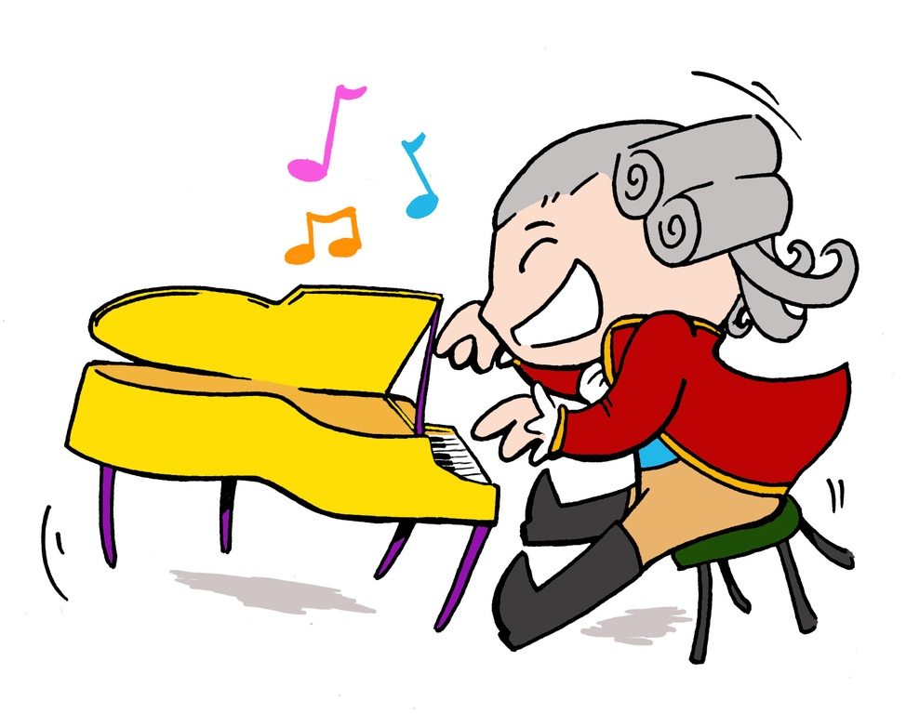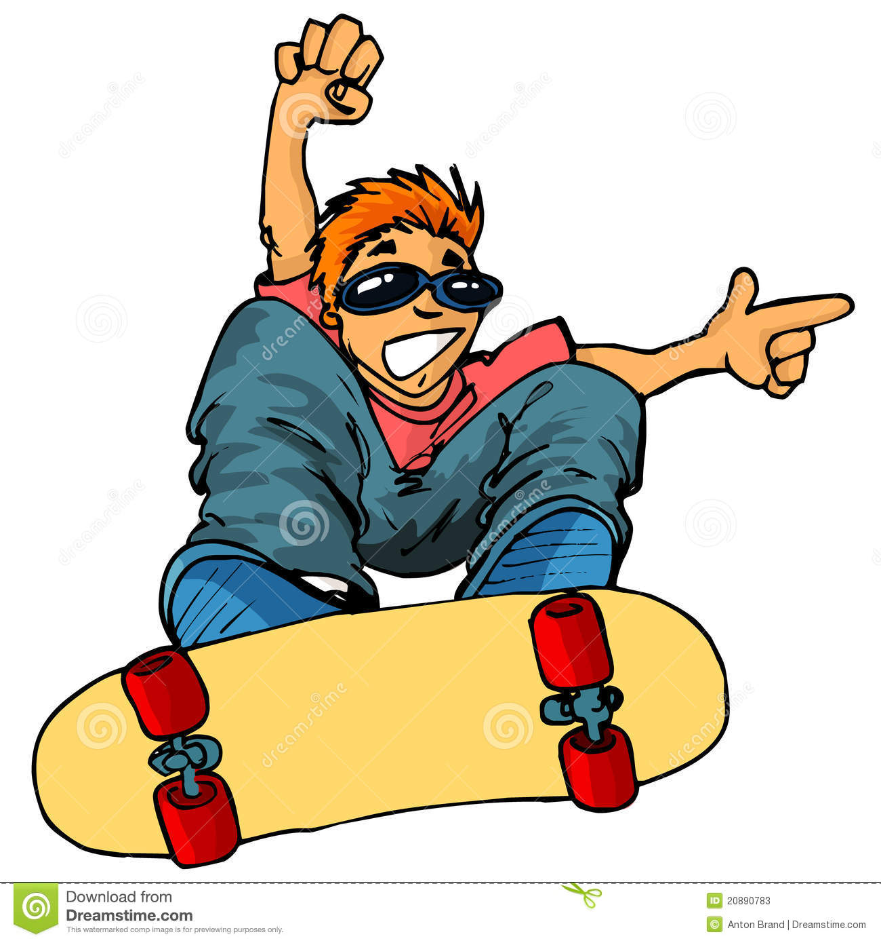

Step 2: Make a BRIEF argument for your skill/activity
-What’s so great about it? Why should we want to learn how to do it?

Step 3: Demonstrate to the audience, step by step, how to DO whatever IT is
-First...next...finally…
-You are actually DOING the activity, showing and explaining to us how to do
whatever you are doing WHILE you are doing it
-Bring in props!

Step 4: Create a script of your speech to help with rehearsing and turn it in to Ms. D before you present!

Time Limits: 2-3 minutes

Due: Wednesday 2/22

Student Name:
CATEGORY | 4 | 3 | 2 | 1 | Score
Speaks Clearly | Speaks clearly and distinctly all (100-95%) the time. | Speaks clearly and distinctly most of the time (80-90%) | Speaks clearly and distinctly about half the time. | Often mumbles or can not be understood.
Posture and Eye Contact | Stands up straight, looks relaxed and confident. Establishes eye contact with everyone in the room during the presentation. | Stands up straight and establishes eye contact with everyone in the room during the presentation. | Sometimes stands up straight and establishes eye contact. | Slouches and/or does not look at people during the presentation.
Content | Explains in detail each part of the activity and why it’s great, giving step-by-step instructions and demonstrations. | Explains in detail most part of the activity and why it’s great, giving step-by-step instructions and demonstrations. | Explains most parts of the activity, giving general instructions and some demonstrations. | Explanation of activity is superficial, skips steps with few to no demonstrations.
Volume | Volume is loud enough to be heard by all audience members throughout the presentation. | Volume is loud enough to be heard by all audience members at least 90% of the time. | Volume is loud enough to be heard by all audience members at least 80% of the time. | Volume often too soft to be heard by all audience members.
Enthusiasm | Facial expressions and body language generate a strong interest and enthusiasm about the topic in others. | Facial expressions and body language sometimes generate a strong interest and enthusiasm about the topic in others. | Facial expressions and body language are used to try to generate enthusiasm, but seem somewhat faked. | Very little use of facial expressions or body language. Did not generate much interest in topic being presented.
Speaking Time | Stays within 2-3 minutes | Speech is less than 2 minutes or more than 3 minutes | Speech is less than 1 minute or over 4 minutes | Speech is less than 30 seconds

Total Points:

